Sri Lanka Institute of Information

Technology



Lab Submission

<Lab sheet No 09>

**<IT24102239>**

**<Vithanage R.A.I.>**

**Probability and Statistics | IT2120**

B.Sc. (Hons) in Information Technology

**Exercise**

**(1)**





**(i)**

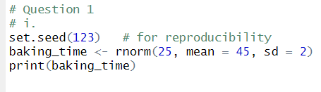

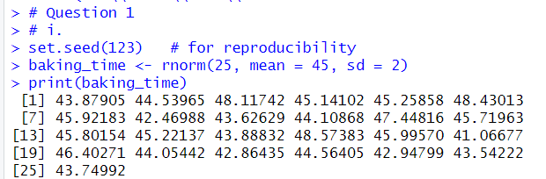

**(ii)**

